Parcel 79

123 Stowell Ave, City of Olean

|  |  |  |  |  |  |  |  |  |  |  |
| --- | --- | --- | --- | --- | --- | --- | --- | --- | --- | --- |
| http://maps.cattco.org/imate/quickstream.aspx?file=VOLLOCAL/Rel2017/041200094067000802000000000003.jpg&thumb=true&width=201&height=152 | | | | | **Status:** | | Active | | | |
| **Roll Section:** | | Taxable | | | |
| **Swis:** | | 041200 | | | |
| **Tax Map ID #:** | | 94.067-8-20 | | | |
| **Property Class:** | | 210 - 1 Family Res | | | |
| **Site:** | | RES 1 | | | |
| **In Ag. District:** | | No | | | |
| **Site Property Class:** | | 210 - 1 Family Res | | | |
| **Zoning Code:** | | - | | | |
| **Neighborhood Code:** | | 12205 | | | |
| **Total Acreage/Size:** | | | 52 x 92.7 | | **School District:** | | Olean | | | |
| **Land Assessment:** | | | 2017 - $4,200 | | **Total Assessment:** | | 2017 - $53,000 | | | |
| **Full Market Value:** | | | 2017 - $59,551 | |  | |  | | | |
| **Living Area:** | | | 1,648 sq. ft. | | **First Story Area:** | | | | 824 sq. ft. | |
| **Second Story Area:** | | | 824 sq. ft. | | **Half Story Area:** | | | | 0 sq. ft. | |
| **Finished Basement:** | | | 0 sq. ft. | | **Number of Stories:** | | | | 2 | |
| **Building Style:** | | | Old style | | **Bathrooms (Full - Half):** | | | | 1 - 0 | |
| **Bedrooms:** | | | 4 | | **Kitchens:** | | | | 1 | |
| **Fireplaces:** | | | 0 | | **Basement Type:** | | | | Full | |
| **Porch Type:** | | | Porch-covered | | **Porch Area:** | | | | 60.00 | |
| **Overall Condition:** | | | Normal | | **Overall Grade:** | | | | Average | |
| **Year Built:** | | | 1915 | |  | |  | | | |
| **Structure** | **Size** | | | **Grade** | | **Condition** | | **Year** | |
| Porch-covered | | 5 × 12 | | Average | | Normal | | 1915 | |
| Gar-1.0 detached | | 20 × 24 | | Average | | Normal | | 1915 | |
| Porch-covered | | 5 × 12  MINIMUM BID $5000 | | Average | | Normal | | 1915 | |

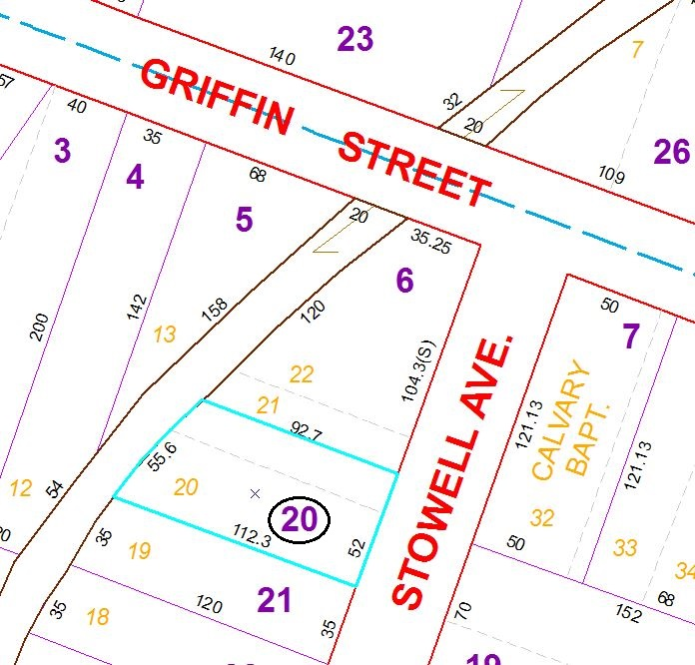

Approximate Yearly Taxes

School $1,384

City $772

County $742

Total $2,898

Special Districts for 2015