Parcel 371

8677 Sawmill Run Rd, Town of Salamanca

|  |  |  |  |  |  |  |  |  |  |  |  |  |
| --- | --- | --- | --- | --- | --- | --- | --- | --- | --- | --- | --- | --- |
| http://maps.cattco.org/imate/quickstream.aspx?file=VOLLOCAL/Rel2017/048000072003000201200000000004.jpg&thumb=true&width=201&height=152 | | | | | | **Status:** | | | | Active | | |
| **Roll Section:** | | | | Taxable | | |
| **Swis:** | | | | 048000 | | |
| **Tax Map ID #:** | | | | 72.003-2-12 | | |
| **Property Class:** | | | | 210 - 1 Family Res | | |
| **Site:** | | | | RES 1 | | |
| **In Ag. District:** | | | | No | | |
| **Site Property Class:** | | | | 210 - 1 Family Res | | |
| **Zoning Code:** | | | | CON | | |
| **Neighborhood Code:** | | | | 80350 | | |
| **Total Acreage/Size:** | | | 231 x 100 | | | **School District:** | | | | Salamanca | | |
| **Land Assessment:** | | | 2017 - $6,600 | | | **Total Assessment:** | | | | 2017 - $43,800 | | |
| **Full Market Value:** | | | 2017 - $50,345 | | |  | | | |  | | |
| **Living Area:** | | 828 sq. ft. | | | **First Story Area:** | | | | | 828 sq. ft. | |
| **Finished Basement:** | | 0 sq. ft. | | |  | | | | |  | |
| **Building Style:** | | Cottage | | | **Bathrooms (Full - Half):** | | | | | 1 - 0 | |
| **Bedrooms:** | | 2 | | | **Kitchens:** | | | | | 1 | |
| **Fireplaces:** | | 0 | | | **Basement Type:** | | | | | Slab/pier | |
| **Porch Type:** | | Porch-covered | | | **Porch Area:** | | | | | 90.00 | |
| **Basement Garage Cap:** | | 0 | | | **Attached Garage Cap:** | | | | | 396.00 sq. ft. | |
| **Overall Condition:** | | Normal | | | **Overall Grade:** | | | | | Economy | |
| **Year Built:** | | 1940 | | |  | | | |  | | |
| **Structure** | **Size** | | | **Grade** | | | **Condition** | **Year** | | |
| Gar-1.0 attached | 18 × 22 | | | Economy | | | Normal | 2001 | | |
| Shed-machine | 12 × 16 | | | Economy | | | Fair | 1960 | | |
| Porch-covered | 15 × 6 | | | Average | | | Normal | 1990 | | |

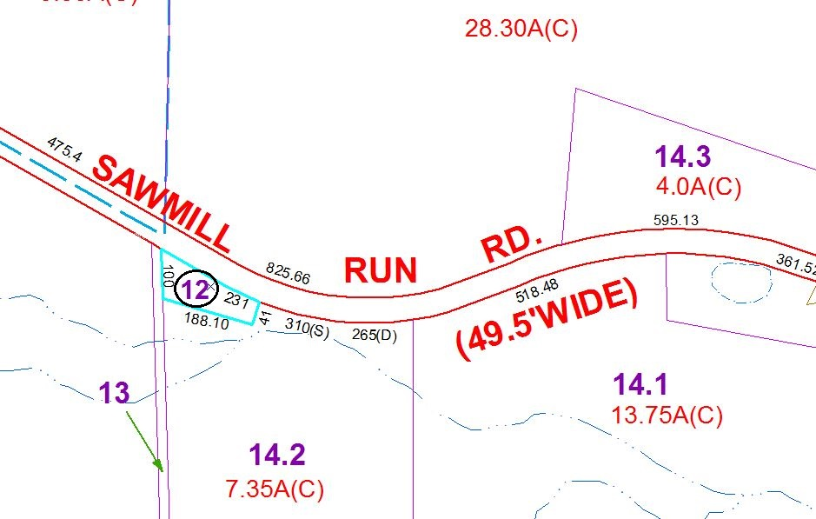

Approximate Yearly Taxes

School $279

Town/County $908

Total $1,187

Special Districts for 2015