Parcel 367

12988 Main St W, Town of Randolph

|  |  |  |  |  |  |  |  |  |  |  |  |  |  |
| --- | --- | --- | --- | --- | --- | --- | --- | --- | --- | --- | --- | --- | --- |
| *See county website*  *For picture* | | | | | | | **Status:** | | | Active | | | |
| **Roll Section:** | | | Taxable | | | |
| **Swis:** | | | 047600 | | | |
| **Tax Map ID #:** | | | 69.004-1-40.3 | | | |
| **Property Class:** | | | 270 – Mfg. housing | | | |
| **Site:** | | | RES 1 | | | |
| **In Ag. District:** | | | No | | | |
| **Site Property Class:** | | | 270 – Mfg. housing | | | |
| **Zoning Code:** | | | - | | | |
| **Neighborhood Code:** | | | 76050 | | | |
| **Total Acreage/Size:** | | | 1.75 | | | | **School District:** | | | Randolph | | | |
| **Land Assessment:** | | | 2017 - $5,700 | | | | **Total Assessment:** | | | 2017 $6,700 | | | |
| **Full Market Value:** | | | 2017 - $8,481 | | | |  | | |  | | |
| **Porch Type:** | Porch-open/deck | | | | **Porch Area:** | | | | 168.00 | | |
| **Structure** | | **Size** | | **Grade** | | **Condition** | | **Year** | | |
| Mobile home | | 60 × 12 | | Average | | Normal | | 1990 | | |
| Mobile Home-wood add | | 12 × 10 | | Economy | | Fair | | 2000 | | |
| Porch-open/deck | | 12 × 14 | | Economy | | Fair  Approximate Yearly Taxes  School $84  Town/County $186  Total $270 | | 2000 | | |

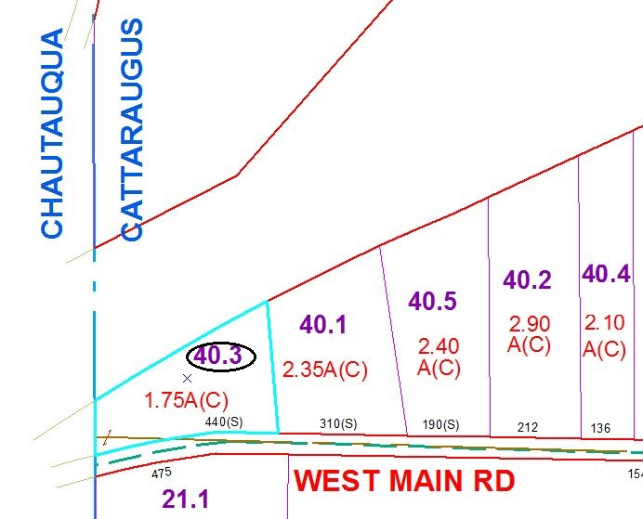

Special Districts for 2015