Parcel 350

Portville Ceres Rd, Town of Portville

|  |  |  |  |  |
| --- | --- | --- | --- | --- |
| *No Photo Available* | | **Status:** | Active | |
| **Roll Section:** | Taxable | |
| **Swis:** | 047489 | |
| **Tax Map ID #:** | 113.002-1-10 | |
| **Property Class:** | 323 - Vacant rural | |
| **Site:** | RES 1 | |
| **In Ag. District:** | No | |
| **Site Property Class:** | 323 - Vacant rural | |
| **Zoning Code:** | CON - CONFORMING | |
| **Neighborhood Code:** | 74050 | |
| **Total Acreage/Size:** | 1.00 | **School District:** | Portville | |
| **Land Assessment:** | 2017 - $10,000 | **Total Assessment:** | 2017 - $10,000 | |
| **Full Market Value:** | 2017 - $10,526  LANDLOCKED  Approximate Yearly Taxes  School $231  Town/County $171  Total $402 |  |  |

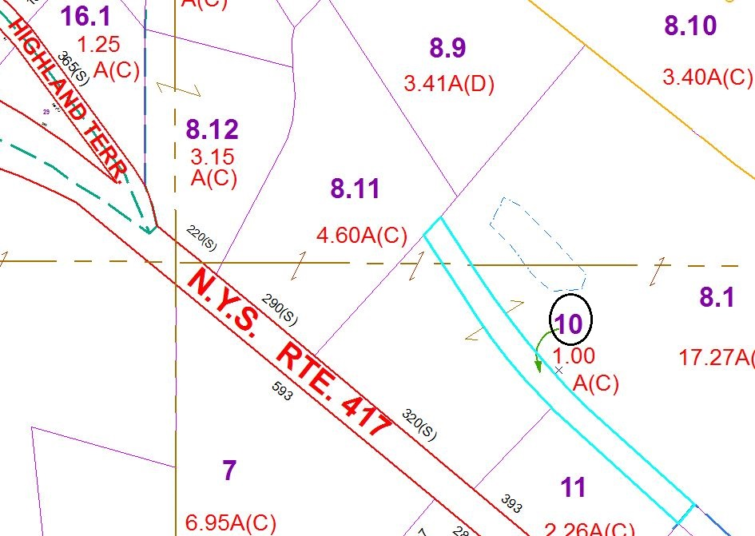

Special Districts for 2015