Parcel 34

257-R Riverside Dr. E, City of Olean

|  |  |  |  |
| --- | --- | --- | --- |
| *No Photo Available* | | **Status:** | Active |
| **Roll Section:** | Taxable |
| **Swis:** | 041200 |
| **Tax Map ID #:** | 94.074-1-21 |
| **Property Class:** | 311 - Res vac land |
| **Site:** | RES 1 |
| **In Ag. District:** | No |
| **Site Property Class:** | 311 - Res vac land |
| **Zoning Code:** | - |
| **Neighborhood Code:** | 12209 |
| **Total Acreage/Size:** | 25.37 | **School District:** | Olean |
| **Land Assessment:** | 2017 - $3,500 | **Total Assessment:** | 2017 - $3,500 |
| **Full Market Value:** | 2017 - $3,933 |  |  |

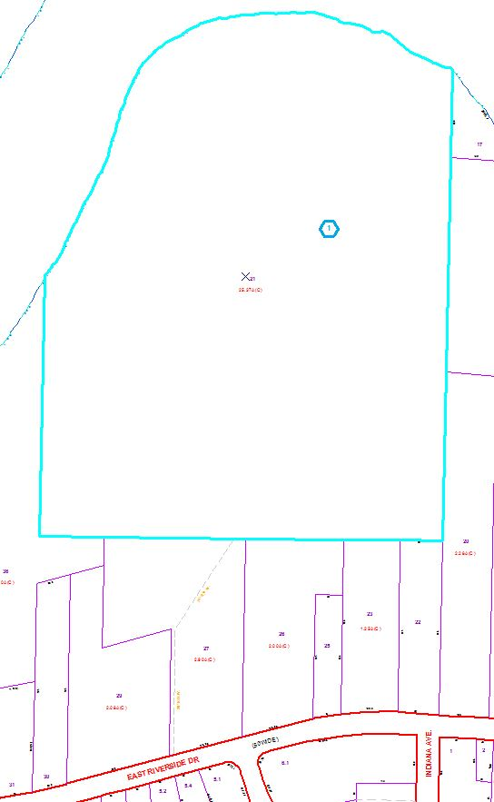

Approximate Yearly Taxes

School $92

City $51

County $49

Total $192

Special Districts for 2015