Parcel 332

11855 Main St, Town of Perrysburg

|  |  |  |  |  |
| --- | --- | --- | --- | --- |
| *NO PHOTO AVAILABLE* | | **Status:** | Active | |
| **Roll Section:** | Taxable | |
| **Swis:** | 047000 | |
| **Tax Map ID #:** | 16.022-2-33 | |
| **Property Class:** | 330 - Vacant comm. | |
| **Site:** | COM 1 | |
| **In Ag. District:** | No | |
| **Site Property Class:** | 330 - Vacant comm. | |
| **Zoning Code:** | - | |
| **Neighborhood Code:** | 70150 | |
| **Total Acreage/Size:** | 51 x 109 | **School District:** | Gowanda | |
| **Land Assessment:** | 2017 - $2,300 | **Total Assessment:** | 2017 - $2,300 | |
| **Full Market Value:** | 2017 - $3,485  Approximate Yearly Taxes  School $59  Town/County $65  Total $124 |  |  |

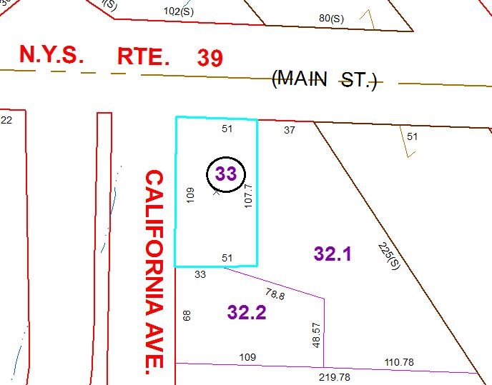

Special Districts for 2015