Parcel 307

74 Main St N, Village of Cattaraugus

|  |  |  |  |  |  |  |  |  |  |  |  |  |  |
| --- | --- | --- | --- | --- | --- | --- | --- | --- | --- | --- | --- | --- | --- |
| http://maps.cattco.org/imate/quickstream.aspx?file=VOLLOCAL/Rel2017/046401035081000100700000000009.jpg&thumb=true&width=201&height=152 | | | | | | **Status:** | | | Active | | | | |
| **Roll Section:** | | | Taxable | | | | |
| **Swis:** | | | 046401 | | | | |
| **Tax Map ID #:** | | | 35.081-1-7 | | | | |
| **Property Class:** | | | 210 - 1 Family Res | | | | |
| **Site:** | | | RES 1 | | | | |
| **In Ag. District:** | | | No | | | | |
| **Site Property Class:** | | | 210 - 1 Family Res | | | | |
| **Zoning Code:** | | | - | | | | |
| **Neighborhood Code:** | | | 00000 | | | | |
| **Total Acreage/Size:** | | | 110 x 173 | | | **School District:** | | | Cattaraugus - Little Valley | | | | |
| **Land Assessment:** | | | 2017 - $3,000 | | | **Total Assessment:** | | | 2017 - $10,000 | | | | |
| **Full Market Value:** | | | 2017 - $15,152 | | |  | | |  | | | |
| **Living Area:** | | 980 sq. ft. | | | **First Story Area:** | | | | | 820 sq. ft. | |
| **Second Story Area:** | | 0 sq. ft. | | | **Half Story Area:** | | | | | 160 sq. ft. | |
| **Finished Basement:** | | 0 sq. ft. | | | **Number of Stories:** | | | | | 1.5 | |
| **Building Style:** | | Old style | | | **Bathrooms (Full - Half):** | | | | | 1 - 0 | |
| **Bedrooms:** | | 3 | | | **Kitchens:** | | | | | 1 | |
| **Fireplaces:** | | 0 | | | **Basement Type:** | | | | | Crawl | |
| **Porch Type:** | | Porch-covered | | | **Porch Area:** | | | | | 120.00 | |
| **Overall Condition:** | | Fair | | | **Overall Grade:** | | | | | Economy | |
| **Year Built:** | | 1900 | | |  | | | | |  | |
| **Structure** | **Size** | | | **Grade** | | | **Condition** | **Year** | | |
| Porch-covered | 8 × 15 | | | Average | | | Fair | 1900  Approximate Yearly Taxes  School $206  Village $195  Town/County $261  Total $662 | | |

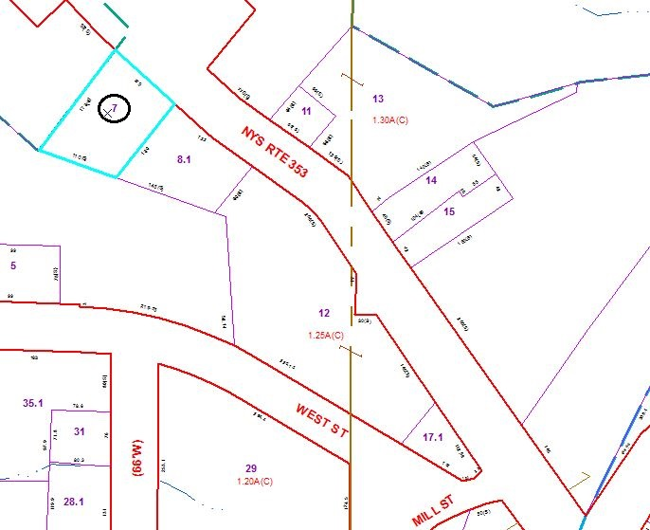

Special Districts for 2015