Parcel 259

212 Fair Oak St, Village of Little Valley

|  |  |  |  |  |  |  |  |  |  |  |  |  |  |
| --- | --- | --- | --- | --- | --- | --- | --- | --- | --- | --- | --- | --- | --- |
| http://maps.cattco.org/imate/quickstream.aspx?file=VOLLOCAL/Rel2017/045401054071000402800000000004.jpg&thumb=true&width=201&height=152 | | | | | **Status:** | | | | Active | | | | |
| **Roll Section:** | | | | Taxable | | | | |
| **Swis:** | | | | 045401 | | | | |
| **Tax Map ID #:** | | | | 54.071-4-28 | | | | |
| **Property Class:** | | | | 210 - 1 Family Res | | | | |
| **Site:** | | | | RES 1 | | | | |
| **In Ag. District:** | | | | No | | | | |
| **Site Property Class:** | | | | 210 - 1 Family Res | | | | |
| **Zoning Code:** | | | | - | | | | |
| **Neighborhood Code:** | | | | 54150 | | | | |
| **Total Acreage/Size:** | | | 66 x 165 | | **School District:** | | | | Cattaraugus - Little Valley | | | | |
| **Land Assessment:** | | | 2017 - $4,600 | | **Total Assessment:** | | | | 2017 - $32,000 | | | | |
| **Full Market Value:** | | | 2017 - $47,761 | |  | | | |  | | | |
| **Living Area:** | | 1,900 sq. ft. | | | **First Story Area:** | | | | | 1,157 sq. ft. | |
| **Second Story Area:** | | 743 sq. ft. | | | **Half Story Area:** | | | | | 0 sq. ft. | |
| **Finished Basement:** | | 0 sq. ft. | | | **Number of Stories:** | | | | | 2 | |
| **Building Style:** | | Old style | | | **Bathrooms (Full - Half):** | | | | | 1 - 0 | |
| **Bedrooms:** | | 4 | | | **Kitchens:** | | | | | 1 | |
| **Fireplaces:** | | 0 | | | **Basement Type:** | | | | | Full | |
| **Porch Type:** | | Porch-covered | | | **Porch Area:** | | | | | 175.00 | |
| **Basement Garage Cap:** | | 0 | | | **Attached Garage Cap:** | | | | | 374.00 sq. ft. | |
| **Overall Condition:** | | Fair | | | **Overall Grade:** | | | | | Average | |
| **Year Built:** | | 1925 | | |  | |  | | | | |
| **Structure** | **Size** | | | **Grade** | | **Condition** | | **Year** | | |
| Gar-1.0 attached | 17 × 22 | | | Average | | Fair | | 1940 | | |
| Porch-covered | 175.00 sq. ft. | | | Average | | Normal | | 2000 | | |

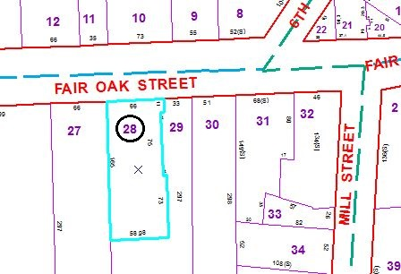

Approximate Yearly Taxes

School $659

Village $489

Town/County $804

Total $1,952

Special Districts for 2015