Parcel 211

11744 Rte. 98, Town of Freedom

|  |  |  |  |  |  |  |  |  |  |
| --- | --- | --- | --- | --- | --- | --- | --- | --- | --- |
| http://maps.cattco.org/imate/quickstream.aspx?file=VOLLOCAL/Rel2017/044200006003000102200000000005.jpg&thumb=true&width=201&height=152 | | | | **Status:** | | Active | | | |
| **Roll Section:** | | Taxable | | | |
| **Swis:** | | 044200 | | | |
| **Tax Map ID #:** | | 6.003-1-22 | | | |
| **Property Class:** | | 210 - 1 Family Res | | | |
| **Site:** | | RES 1 | | | |
| **In Ag. District:** | | No | | | |
| **Site Property Class:** | | 210 - 1 Family Res | | | |
| **Zoning Code:** | | 01 | | | |
| **Neighborhood Code:** | | 04200 - Freedom | | | |
| **Total Acreage/Size:** | | 110 x 317 | | **School District:** | | | | Yorkshire-Pioneer | | |
| **Land Assessment:** | | 2017 - $7,900 | | **Total Assessment:** | | | | 2017 - $106,200 | | |
| **Full Market Value:** | | 2017 - $106,200 | |  | | | |  | | |
| **Living Area:** | | 1,320 sq. ft. | | **First Story Area:** | | | | 1,320 sq. ft. | | |
| **Finished Basement:** | | 0 sq. ft. | | **Number of Stories:** | | | | 1 | | |
| **Building Style:** | | Manuf'd Housing | | **Bathrooms (Full - Half):** | | | | 1 - 1 | | |
| **Bedrooms:** | | 3 | | **Kitchens:** | | | | 1 | | |
| **Fireplaces:** | | 1 | | **Basement Type:** | | | | Slab/pier | | |
| **Porch Type:** | | Porch-open/deck | | **Porch Area:** | | | | 72.00 | | |
| **Overall Condition:** | | Normal | | **Overall Grade:** | | | | Average | | |
| **Year Built:** | | 1995 | |  | |  | | | |
| **Structure** | **Size** | | **Grade** | | **Condition** | | **Year** | |
| Porch-open/deck | 8 × 9 | | Economy | | Fair | | 1971 | |
| Gar-1.0 det. | 24 × 30 | | Average | | Normal | | 1971 | |
| Shed-machine | 12 × 14 | | Economy | | Fair | | 1971 | |
| Porch-enclosed | 8 × 10 | | Average | | Normal | | 1971 | |

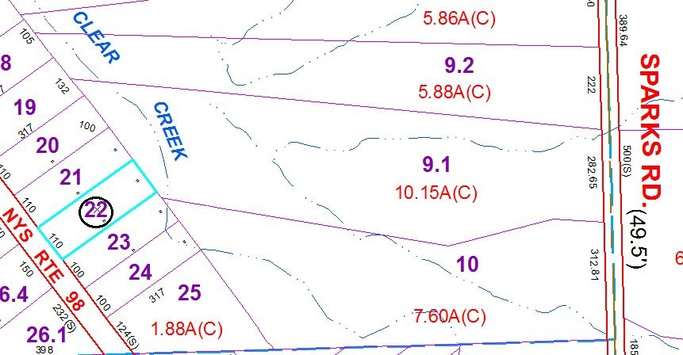

Approximate Yearly Taxes

School $1,432

Town/County $1,864

Total $3,296

Special Districts for 2015