Parcel 160

17 Mill St, Village of South Dayton

|  |  |  |  |  |  |  |  |  |  |
| --- | --- | --- | --- | --- | --- | --- | --- | --- | --- |
| http://maps.cattco.org/imate/quickstream.aspx?file=VOLLOCAL/Rel2017/043001033034000300100200000008.jpg&thumb=true&width=201&height=152 | | | | **Status:** | | Active | | | |
| **Roll Section:** | | Taxable | | | |
| **Swis:** | | 043001 | | | |
| **Tax Map ID #:** | | 33.034-3-1.2 | | | |
| **Property Class:** | | 270 – Mfg. housing | | | |
| **Site:** | | RES 1 | | | |
| **In Ag. District:** | | No | | | |
| **Site Property Class:** | | 270 – Mfg. housing | | | |
| **Zoning Code:** | | - | | |
| **Neighborhood Code:** | | 30080 | | |
| **Total Acreage/Size:** | | 69.5 x 200 | | **School District:** | | Pine Valley | | |
| **Land Assessment:** | | 2017 - $1,800 | | **Total Assessment:** | | 2017 - $45,000 | | |
| **Full Market Value:** | | 2017 - $45,000 | |  | |  | | |
| **Structure** | **Size** | | **Grade** | | **Condition** | | **Year** |
| Mobile home | 70 × 14 | | Average | | Normal | | 1989 |
| Mobile home | 76 × 16 | | Economy | | Fair | | 2007 |

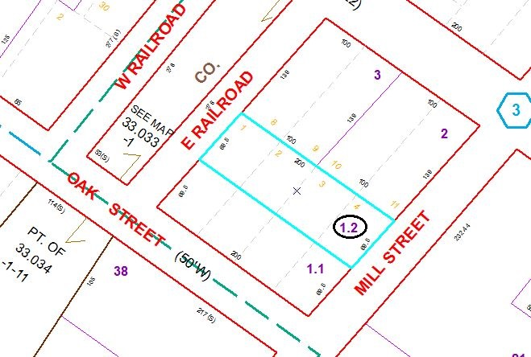

Approximate Yearly Taxes

School $994

Village $581

Town/County $850

Total $2,425

Special Districts for 2015