Parcel 131

5437 Nichols Run Rd, Town of Carrollton

|  |  |  |  |  |  |  |  |  |  |  |  |  |  |  |  |
| --- | --- | --- | --- | --- | --- | --- | --- | --- | --- | --- | --- | --- | --- | --- | --- |
| http://maps.cattco.org/imate/quickstream.aspx?file=VOLLOCAL/Rel2017/042400110002000101300300000004.jpg&thumb=true&width=201&height=152 | | | | | | **Status:** | | | | Active | | | | | |
| **Roll Section:** | | | | Taxable | | | | | |
| **Swis:** | | | | 042400 | | | | | |
| **Tax Map ID #:** | | | | 110.002-1-13.3 | | | | | |
| **Property Class:** | | | | 210 - 1 Family Res | | | | | |
| **Site:** | | | | RES 1 | | | | | |
| **In Ag. District:** | | | | No | | | | | |
| **Site Property Class:** | | | | 210 - 1 Family Res | | | | | |
| **Zoning Code:** | | | | 01 | | | | | |
| **Neighborhood Code:** | | | | 24050 | | | | | |
| **Total Acreage/Size:** | | | 9.90 | | | **School District:** | | | | Allegany - Limestone | | | | | |
| **Land Assessment:** | | | 2017 - $17,900 | | | **Total Assessment:** | | | | 2017 - $74,500 | | | | | |
| **Full Market Value:** | | | 2017 - $86,628 | | |  | | | |  | | | |
| **Living Area:** | | 1,008 sq. ft. | | | **First Story Area:** | | | | | | 1,008 sq. ft. | | | |
| **Finished Basement:** | | 0 sq. ft. | | | **Number of Stories:** | | | | | | 1 | | | |
| **Finished Rec Room** | | 724 sq. ft. | | | **Finished Area Over Garage** | | | | | | 0 sq. ft. | | | |
| **Building Style:** | | Ranch | | | **Bathrooms (Full - Half):** | | | | | | 1 - 0 | | | |
| **Bedrooms:** | | 3 | | | **Kitchens:** | | | | | | 1 | | | |
| **Fireplaces:** | | 0 | | | **Basement Type:** | | | | | | Full | | | |
| **Porch Type:** | | Porch-covered | | | **Porch Area:** | | | | | | 240.00 | | | |
| **Basement Garage Cap:** | | 0 | | | **Attached Garage Cap:** | | | | | | 720.00 sq. ft. | | | |
| **Overall Condition:** | | Normal | | | **Overall Grade:** | | | | | | Good | | | |
| **Year Built:** | | 1983 | | |  | | |  | | | | |
| **Structure** | **Size** | | | **Grade** | | | **Condition** | | **Year** | | |
| Gar-1.0 attached | 30 × 24 | | | Average | | | Normal | | 1983 | | |
| Porch-covered | 12 × 20 | | | Economy | | | Fair | | 1994 | | |

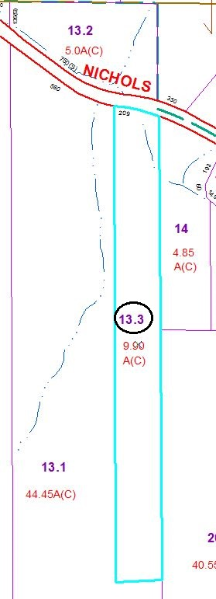

MINIMUM BID $25,000

Approximate Yearly Taxes

School $1,509

Town/County $1,470

Total $2,979

Special Districts for 2015