Parcel 122

1905 Chipmonk Rd, Town of Carrollton

|  |  |  |  |  |  |  |  |  |  |  |  |  |  |
| --- | --- | --- | --- | --- | --- | --- | --- | --- | --- | --- | --- | --- | --- |
| http://maps.cattco.org/imate/quickstream.aspx?file=VOLLOCAL/Rel2017/042400092004000100400200000004.jpg&thumb=true&width=201&height=152 | | | | | | **Status:** | | | | Active | | | |
| **Roll Section:** | | | | Taxable | | | |
| **Swis:** | | | | 042400 | | | |
| **Tax Map ID #:** | | | | 92.004-1-4.2 | | | |
| **Property Class:** | | | | 210 - 1 Family Res | | | |
| **Site:** | | | | RES 1 | | | |
| **In Ag. District:** | | | | No | | | |
| **Site Property Class:** | | | | 210 - 1 Family Res | | | |
| **Zoning Code:** | | | | 01 | | | |
| **Neighborhood Code:** | | | | 24050 | | | |
| **Total Acreage/Size:** | | | 130 x 175 | | | **School District:** | | | | Allegany - Limestone | | | |
| **Land Assessment:** | | | 2017 - $6,100 | | | **Total Assessment:** | | | | 2017 - $39,000 | | | |
| **Full Market Value:** | | | 2017 - $45,349 | | |  | | | |  | | |
| **Living Area:** | | 1,196 sq. ft. | | | **First Story Area:** | | | | | 956 sq. ft. | |
| **Second Story Area:** | | 240 sq. ft. | | | **Half Story Area:** | | | | | 0 sq. ft. | |
| **Finished Basement:** | | 0 sq. ft. | | | **Number of Stories:** | | | | | 2 | |
| **Building Style:** | | Old style | | | **Bathrooms (Full - Half):** | | | | | 1 - 1 | |
| **Bedrooms:** | | 3 | | | **Kitchens:** | | | | | 1 | |
| **Fireplaces:** | | 0 | | | **Basement Type:** | | | | | Partial | |
| **Porch Type:** | | Porch-enclosed | | | **Porch Area:** | | | | | 120.00 | |
| **Overall Condition:** | | Normal | | | **Overall Grade:** | | | | | Economy | |
| **Year Built:** | | 1940 | | |  | | |  | | | |
| **Structure** | **Size** | | | **Grade** | | | **Condition** | | **Year** | |
| Porch-enclosed | 20 × 6 | | | Average | | | Normal | | 1940 | |
| Porch-enclosed | 10 × 6 | | | Average | | | Normal | | 1940 | |
| Gar-1.0 detached | 54 × 20 | | | Average | | | Fair | | 1940 | |
| Porch-covered | 24.00 sq. ft. | | | Average | | | Normal | | 1940 | |

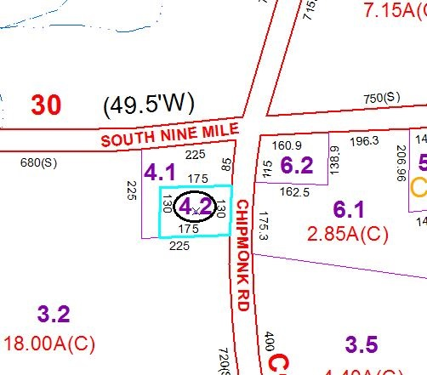

Approximate Yearly Taxes

School $790

Town/County $770

Total $1,560

Special Districts for 2015