Parcel 100

Celeste Dr. Off, Town of Allegany

|  |  |  |  |
| --- | --- | --- | --- |
| *No Photo Available* | | **Status:** | Active |
| **Roll Section:** | Taxable |
| **Swis:** | 042089 |
| **Tax Map ID #:** | 93.036-1-2.5 |
| **Property Class:** | 314 - Rural vac<10 |
| **Site:** | RES 1 |
| **In Ag. District:** | No |
| **Site Property Class:** | 314 - Rural vac<10 |
| **Zoning Code:** | - |
| **Neighborhood Code:** | 20314 |
| **Total Acreage/Size:** | 4.45 | **School District:** | Allegany - Limestone |
| **Land Assessment:** | 2017 - $37,600 | **Total Assessment:** | 2017 - $37,600 |
| **Full Market Value:** | 2017 - $38,763 |  |  |

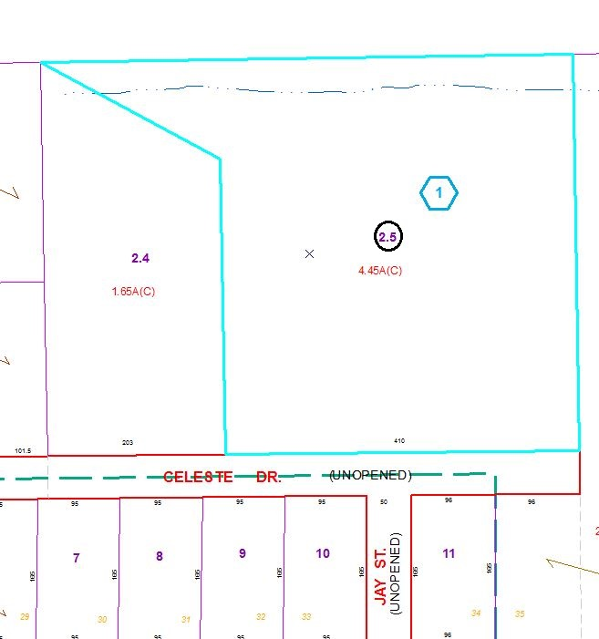

Approximate Yearly Taxes

School $663

Town/County $722

Total $1,385

Special Districts for 2015