Parcel 9

616 Henley St W, City of Olean

|  |  |  |  |  |  |  |  |  |  |  |  |  |  |  |
| --- | --- | --- | --- | --- | --- | --- | --- | --- | --- | --- | --- | --- | --- | --- |
| http://maps.cattco.org/Imate/quickstream.aspx?file=VOLLOCAL/Rel2016/041200094064001303100000000006.jpg&thumb=true&width=201&height=152 | | | | | | | | **Status:** | | | | Active | | |
| **Roll Section:** | | | | Taxable | | |
| **Swis:** | | | | 041200 | | |
| **Tax Map ID #:** | | | | 94.064-13-31 | | |
| **Account #:** | | | | 024440 | | |
| **Property Class:** | | | | 220 - 2 Family Res | | |
| **Site:** | | | | RES 1 | | |
| **In Ag. District:** | | | | No | | |
| **Site Property Class:** | | | | 220 - 2 Family Res | | |
| **Zoning Code:** | | | | - | | |
| **Neighborhood Code:** | | | | 12204 | | |
| **Total Acreage/Size:** | | | | 45 x 107 | | | | **School District:** | | | | Olean | | |
| **Land Assessment:** | | | | 2016 - $3,600 | | | | **Total Assessment:** | | | | 2016 - $43,900 | | |
| **Full Market Value:** | | | | 2016 - $47.717 | | | |  | | | |  | | |
| **Living Area:** | | | 2,322 sq. ft. | | | **First Story Area:** | | | | | 1,308 sq. ft. | | |
| **Second Story Area:** | | | 720 sq. ft. | | | **Half Story Area:** | | | | | 294 sq. ft. | | |
| **Finished Basement:** | | | 0 sq. ft. | | | **Number of Stories:** | | | | | 2 | | |
| **Building Style:** | | | Old style | | | **Bathrooms (Full - Half):** | | | | | 2 - 1 | | |
| **Bedrooms:** | | | 3 | | | **Kitchens:** | | | | | 2 | | |
| **Fireplaces:** | | | 0 | | | **Basement Type:** | | | | | Full | | |
| **Porch Type:** | | | Porch-covered | | | **Porch Area:** | | | | | 18.00 | | |
| **Overall Condition:** | | | Fair | | | **Overall Grade:** | | | | | Average | | |
| **Year Built:** | | | 1900 | | |  | | |  | | | | |
| **Structure** | **Size** | | | | **Grade** | | **Condition** | | | **Year** | | |  | | |
| Porch-covered | | 3 × 6 | | | Economy | | Poor | | | 1900 | | |  | | |
| Porch-enclosed | | 7 × 14 | | | Average | | Normal | | | 1900 | | |  | | |
| Carport | | 12 × 14 | | | Economy | | Fair | | | 1970 | | |  | | |

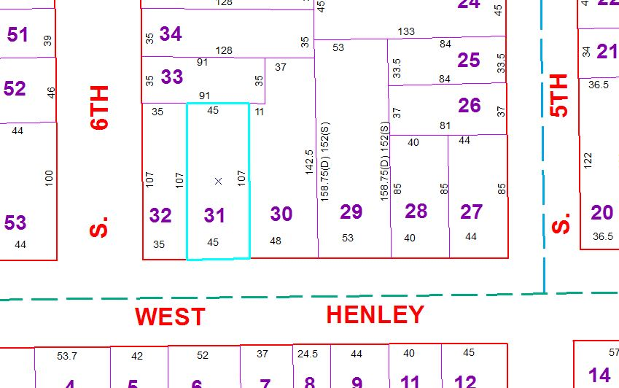

Approximate Yearly Taxes

School $1,125

City $599

County $633

Total $2,357