Parcel 303

2640 Swarts Rd, Town of Olean

|  |  |  |  |  |  |  |  |  |  |  |  |
| --- | --- | --- | --- | --- | --- | --- | --- | --- | --- | --- | --- |
| http://maps.cattco.org/Imate/quickstream.aspx?file=VOLLOCAL/Rel2016/046600103003000202200000000006.jpg&thumb=true&width=201&height=152 | | | | | | **Status:** | | | Active | | |
| **Roll Section:** | | | Taxable | | |
| **Swis:** | | | 046600 | | |
| **Tax Map ID #:** | | | 103.003-2-22 | | |
| **Account #:** | | | 0401 | | |
| **Property Class:** | | | 281 - Multiple res | | |
| **Site:** | | | RES 1 | | |
| **In Ag. District:** | | | No | | |
| **Site Property Class:** | | | 281 - Multiple res | | |
| **Zoning Code:** | | | - | | |
| **Neighborhood Code:** | | | 66350 | | |
| **Total Acreage/Size:** | | 1.64 | | | | **School District:** | | | Olean | | |
| **Land Assessment:** | | 2016 - $4,400 | | | | **Total Assessment:** | | | 2016 - $51,900 | | |
| **Full Market Value:** | | 2016 - $66,538 | | | |  | | |  | | |
| **Living Area:** | 1,440 sq. ft. | | | **First Story Area:** | | | 1,440 sq. ft. | | | |
| **Finished Basement:** | 0 sq. ft. | | | **Number of Stories:** | | | 1 | | | |
| **Building Style:** | Ranch | | | **Bathrooms Full - Half:** | | | 2 - 0 | | | |
| **Bedrooms:** | 3 | | | **Kitchens:** | | | 1 | | | |
| **Fireplaces:** | 0 | | | **Basement Type:** | | | Slab/pier | | | |
| **Porch Type:** | Porch-covered | | | **Porch Area:** | | | 32.00 | | | |
| **Overall Condition:** | Fair | | | **Overall Grade:** | | | Economy | | | |
| **Year Built:** | 1993 | | |  | | |  | | | |
| **Structure** | **Size** | | **Grade** | | **Condition** | | | **Year** | |  | | |
| Mh:wood add | 12 × 8 | | Economy | | Fair | | | 1982 | |  | | |
| Gar-1.0 detached | 40 × 42 | | Economy | | Fair | | | 1982 | |  | | |
| Mobile home | 70 × 14 | | Economy | | Fair | | | 1982 | |  | | |
| Porch-covered | 8 × 4 | | Economy | | Fair | | | 1982 | |  | | |

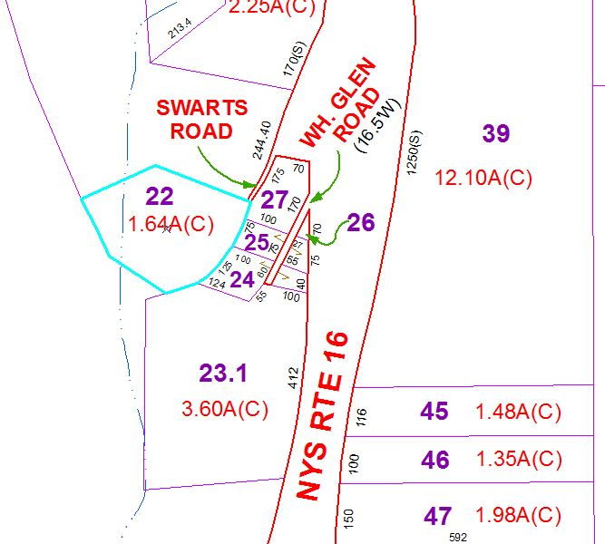

Approximate Yearly Taxes

School $1,620

Town/County $1,163

Total $2,783