Parcel 284

6779 NYS Rte 353, Town of New Albion

|  |  |  |  |  |  |  |  |  |  |  |  |  |  |  |
| --- | --- | --- | --- | --- | --- | --- | --- | --- | --- | --- | --- | --- | --- | --- |
| http://maps.cattco.org/Imate/quickstream.aspx?file=VOLLOCAL/Rel2016/046489044004000201900200000003.jpg&thumb=true&width=201&height=152 | | | | | | | **Status:** | | | Active | | | | |
| **Roll Section:** | | | Taxable | | | | |
| **Swis:** | | | 046489 | | | | |
| **Tax Map ID #:** | | | 44.004-2-19.2 | | | | |
| **Account #:** | | | 1081 | | | | |
| **Property Class:** | | | 270 – Mfg. housing | | | | |
| **Site:** | | | RES 1 | | | | |
| **In Ag. District:** | | | No | | | | |
| **Site Property Class:** | | | 270 – Mfg. housing | | | | |
| **Zoning Code:** | | | - | | | | |
| **Neighborhood Code:** | | | 64350 | | | | |
| **Total Acreage/Size:** | | | 6.70 | | | | **School District:** | | | Cattaraugus - Little Valley | | | | |
| **Land Assessment:** | | | 2016 - $8,800 | | | | **Total Assessment:** | | | 2016 - $20,000 | | | | |
| **Full Market Value:** | | | 2016 - $28,169 | | | |  | | |  | | |
| **Porch Type:** | | Porch-covered | | | **Porch Area:** | | | 240.00 | | | |
| **Structure** | | **Size** | | | **Grade** | | | **Condition** | | | |
| Porch-covered | 24 × 10 | | | Economy | | Fair | | | **Year** | |  | | |
| Mobile home | 56 × 34 | | | Economy | | Fair | | | 1972 | |  | | |
| Shed-machine | 10 × 8 | | | Average | | Normal | | | 1972 | |  | | |
|  |  | | |  | |  | | |  | |  | | |

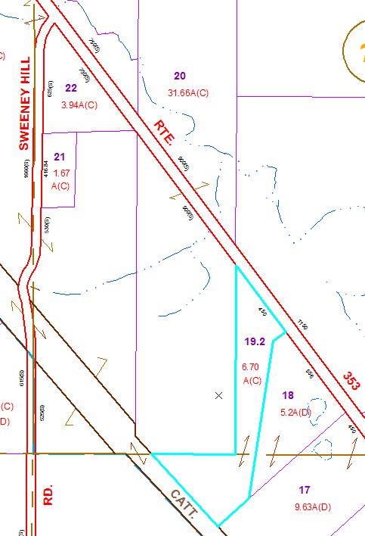

Approximate Yearly Taxes

School $ 429

Town/County $ 589

Total $1,018

|  |  |  |
| --- | --- | --- |
|  |  |  |