Parcel 26

306 Eleventh St N, City of Olean

|  |  |  |  |  |  |  |  |  |  |  |  |  |
| --- | --- | --- | --- | --- | --- | --- | --- | --- | --- | --- | --- | --- |
| http://maps.cattco.org/Imate/quickstream.aspx?file=VOLLOCAL/Rel2016/041200094056000302700000000006.jpg&thumb=true&width=201&height=152 | | | | | | | **Status:** | | | Active | | |
| **Roll Section:** | | | Taxable | | |
| **Swis:** | | | 041200 | | |
| **Tax Map ID #:** | | | 94.056-3-27 | | |
| **Account #:** | | | 011910 | | |
| **Property Class:** | | | 210 - 1 Family Res | | |
| **Site:** | | | RES 1 | | |
| **In Ag. District:** | | | No | | |
| **Site Property Class:** | | | 210 - 1 Family Res | | |
| **Zoning Code:** | | | - | | |
| **Neighborhood Code:** | | | 12204 | | |
| **Total Acreage/Size:** | | | 45 x 67 | | | | **School District:** | | | Olean | | |
| **Land Assessment:** | | | 2016 - $2,800 | | | | **Total Assessment:** | | | 2016- $34,000 | | |
| **Full Market Value:** | | | 2016 - $36,957 | | | |  | | |  | | |
| **Living Area:** | | 1,456 sq. ft. | | | **First Story Area:** | | | | 800 sq. ft. | | |
| **Second Story Area:** | | 656 sq. ft. | | | **Half Story Area:** | | | | 0 sq. ft. | | |
| **Finished Basement:** | | 0 sq. ft. | | | **Number of Stories:** | | | | 2 | | |
| **Building Style:** | | Old style | | | **Bathrooms (Full - Half):** | | | | 2 - 0 | | |
| **Bedrooms:** | | 3 | | | **Kitchens:** | | | | 1 | | |
| **Fireplaces:** | | 0 | | | **Basement Type:** | | | | Crawl | | |
| **Porch Type:** | | Porch-covered | | | **Porch Area:** | | | | 48.00 | | |
| **Overall Condition:** | | Normal | | | **Overall Grade:** | | | | Average | | |
| **Year Built:** | | 1895 | | |  | | | |  | | |
| **Structure** | **Size** | | | **Grade** | | **Condition** | | **Year** | | |  | | |
| Porch-covered | 4 × 12 | | | Average | | Normal | | 1895 | | |  | | |
| Porch-covered | 5 × 5 | | | Average | | Normal | | 1895 | | |  | | |
| User defined |  | | | Average | | Fair | | 1970 | | |  | | |

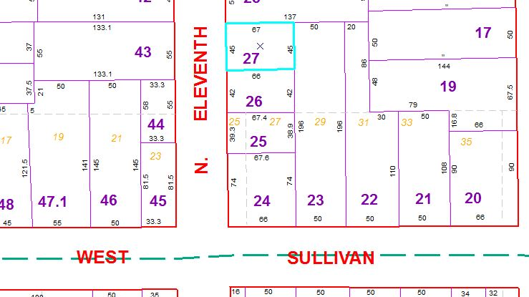

Approximate Yearly Taxes

School $871

City $491

County $464

Total $1,826